

Faculty of Technology

Pulse Amplifier

Contents

Contents 1
SAFETY 2
Introduction 2
Safety: All Laboratories 2
Specific to This Exercise – 2
Soldering 2
Clipping Component Leads 2
Pulse Amplifier Project 3
Introduction 3
Circuit Description 4
Pulse Transducer 4
Filtering and Amplification 4
Comparator 4
Transistor Stage 5
TTL Output 5
LDR (Light Dependant Resistor) Sensor 6
Resistively and Resistance 6
Manufacture 7
Characteristics 7
ASSEMBLY OF THE PCB 8
Schematic Layout 9
PCB Component and Layout 9
Parts List 10
Component Recognition 11

SAFETY

Introduction
- These guidelines are intended to help in making Faculty Communication and Electronics Laboratories a safe working environment for all users.

Safety: All Laboratories
- Do not power up equipment until authorised to do so by a member of staff.
- Some equipment is potentially dangerous. Never operate equipment, which you are not familiar with or competent to use.
- Always switch off equipment after you have finished using it. Note. Networked PCs are to be left running.
- Never use faulty equipment, report it immediately to a member of staff.
- Never open or attempt to repair equipment unless instructed to do so by a member of staff.
- Keep gangways clear of obstructions. If you need to keep bags or other articles with you, store them so as not to cause a trip or other hazard to others.
- Do not “ride” chairs; this is not only dangerous to you but a hazard to others.
- Tidy your work area before leaving the laboratory.
- If you see something that you think is unsafe report it immediately to a member of staff.
- Remember eating and drinking is not permitted in any University of Plymouth laboratory.

Specific to This Exercise –

Eye protection is to be worn at all times when soldering components or trimming wires.

Soldering
Soldering irons must always be placed in their stands when not in use.
Soldering Iron bits must be cleaned using a wet sponge, the practice of flicking or tapping the iron to remove solder from the tip is not only bad practice but also highly dangerous and will not be tolerated.

Only solder cored with “Colophony Free” flux is to be used in the University; solder brought into the University will require a COSHH and Risk assessments to be completed before it is used.

Solders may contain lead always wash your hands after soldering.

Clipping Component Leads
Always ensure that the clipping do not fly towards other people. Direct the off-cut towards the bench or cover with you hands to keep then contained.

Pulse Amplifier Project

Introduction

The ability to sense or measure light is a useful thing to be able to do and allows us to automate many operations; it can be seen in action almost everyday in one form or another.

The switching on and off of street lamps or home security lights are examples of simple tasks which have been automated by using a light sensor and some electronics.

In this project we use the ability to sense light to measure the pulse in a human finger. The principle of operation is to flood the finger, which is translucent, with a red light and measure the reflected light value with a sensor. The level of received light will fluctuate due to the changing density of blood being pumped though the finger by the heart.

We are going to build a simple project using a pulse transducer; operational amplifies in two basic configurations, the amplifier and comparator and a simple transistor switch will allow the output to flash an LED and provide a digital level output for connection to other circuits or computer. The assembled PCB is shown below Figure 1.

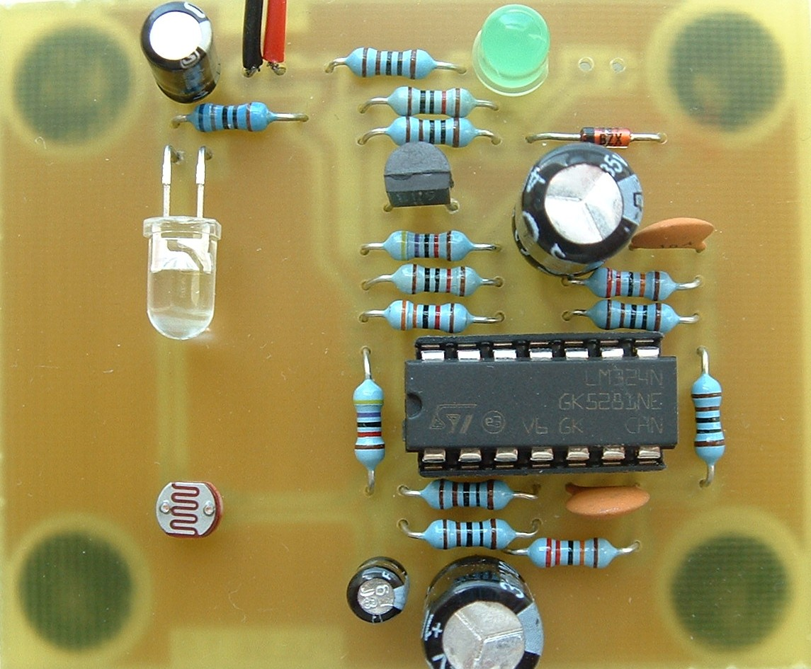

Figure 1 – Pulse Amplifier.

Circuit Description

Pulse Transducer

The LED and LDR together form a pulse transducer; an electronic transducer is a device that converts energy from one form to another.

The Red LED, D1, is used as a light source to flood the finger tip with a constant level of RED light. Some of this will illuminate the Light Dependant Resistor LDR1. As blood is pumped through the finger by the heart the density of blood within the finger will vary which in turn will vary the amount of light reaching the LDR. This variation is detected by the LDR1 and converted into an electrical signal (very small).

Resistor R1 will limit the current through D1 (red LED) to about 10mA. The characteristics of the LED are such that the forward volt drop across D1 is essentially stable at about 1.8volts, and provides a reference for the input stage (C1 provides filtering and ensures that this reference is noise free).
The LDR in combination with R2 form a potential divider across this reference voltage with the potential divider output proportional to the amount of light entering the LDR via the finger. The variations in the density of blood flow (pulse) produce a proportional change in voltage at this point. This signal is quite small, about 150μV with a frequency of around 1Hz to 0.5Hz (60 to 120 Beats /min). Unfortunately it also contains a larger unwanted but unavoidable signal (10 to 100 times) of 50Hz ‘Mains Hum’. Fortunately however this frequency is 50 to 100 times higher than the pulse rate, making it relatively easy to remove by filtering.

Filtering and Amplification
Low pass filtering is used throughout (since the pulse is much lower in frequency than the ‘hum).
The initial filtering is performed by LDR1 and C2, (C2 impedance being about 300ohms at 50Hz and 16,000ohms at 1Hz). The signal is then passed to U1:A a high impedance unity gain non inverting amplifier.
The output of U1:A is then fed via R3 to the inverting input of U1:B an inverting amplifier which has a gain of 220 at pulse rate, but only a gain of about 30 at 50Hz due to the impedance of C4 in parallel with the feedback resistor). The output of U1:A is also fed via R4 and C3 (forming a low pas filter)to the non-inverting input, making this point equal to the average of that applied to the inverting input.
The final stage of amplification / filtering is performed within U1:C in the same manner as above. The output of this stage, following two stages of amplification is approximately 5V, this is fed to the inverting input of U1: D, the comparator.

Comparator
This stage in an operational amplifier wired as a comparator with hysterisis. In electronics a comparator is a device which compares two voltages or currents and switches its output to indicate which is larger. Hysterisis is the property that prevents the output instanly following the input and in this case provide stability to the output sinal.
The comparator’s non-inverting input is held at a reference voltage of approximately 7V (potential divider R9 and R10). In this configuration the output of the comparator will be ‘low’ (≈0V) if the inverting input is at a higher potential than its non-inverting input (reference). If the potential on the inverting input falls below that of the reference, then the output state will ‘switch’, becoming ‘high’ (≈9V). The output is stabilised by applying hysterisis to the reference input (via R11); artificially raising the reference voltage as the output switches. This means that the circuit will not switch back again until the input has risen to a higher voltage than that which switched it originally. When this occurs the output switching the other way will cause the reference voltage to reduce again.

Transistor Stage
The detected pulse is indicated by a Green LED; however the comparator is not capable of supplying enough current to light the ‘Pulse Indicator’ directly therefore a simple transistor stage (R12, Q1, D2, and R13) has been added to enable this. A positive voltage applied to the base of the transistor through R12 will cause it to “switch”. The transistor in this configuration will amplify the current flowing into its base by allowing a much larger current to flow from its collector to emitter. The effect of this is to draw this larger current from the supply through R13 and D2 illuminating the Green LED.

TTL Output
Resistor R14 and Zener diode D3 have been added to provide a TTL compatible 0V to 5V output suitable for most logic and computer inputs from the 0V to9V level at the collector of Q1. This signal could be applied to a microprocessor / microcontroller which with suitable hardware and software could show the results as a pulse rate of Beats / min’. R14 provides the current limiting for the diode.

LDR (Light Dependant Resistor) Sensor
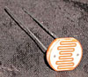
The Light Dependant Resistor Figure 2 which can also be known as a Photo Resistor or Photo Conductor is an electronic component made of high resistance semiconductor material whose resistance reduces as the amount of light shining on it increases. The device we will be looking at in this exercise is a low cost Cadmium Sulphide (CdS) device readily available from most electronic suppliers.

Figure 2 - Light Dependent Resistor

Resistively and Resistance

The resistivity of a material is a measure of how a material resists the flow of electrical current. And as you can see from the comparison table (Table 1), a conductor is pretty good at conducting electric current with a low resistivity; useful for connecting wires etc. and the Insulator is a pretty poor conductor; useful if you don’t want electricity to flow through handle of your electric kettle for instance. The semiconductors sit between the two types of material, exactly where will depend on the semiconductor material and its purity.
ρ = Rl
A

Resistivity is expressed as Rho Ω/Meter

Where ρ Rho is the resistivity, R the resistance (Ω), l the length and A the cross sectional area.

Rearranged we can see that the resistance of a piece of material is proportional to its length divided by its cross sectional area multiplied by the resistivity of the material.

R = ρ l
A

Material | Resistivity | Effect of Temperature
Conductor | 10-8 Ohms / Meter | Slight increase with temp
Insulator | 1011 Ohms / Meter | Slight increase with temp
Semiconductor | 10-6 to 104 Ohms / Meter | Decrease exponentially with Temperature.

Table 1

Manufacture
The LDR is manufactured by adding impurities and a fusing agent to very pure CdS crystal powder and then mixing with water. The resulting paste is screened over the ceramic substrate to provide an even coating. The coated substrate is then sintered at a high temperature to grow the CdS crystals; this will give a thick photo sensitive layer. Lead terminals and connecting wires are then added to the surface; the whole device is then protected in a clear plastic coating.

A diagram of the construction of a LDR is shown in Figure 3 below. The serpentine pattern across and the border around the device is the exposed photosensitive layer; it isolates the two areas forming the terminals but at the same time presents a large cross sectional area through which the current can flow.

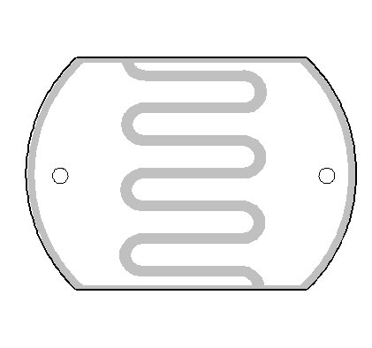

CdS Coating

Lead Terminals

Connecting Wires

Figure 3

Characteristics
LDRs are usually quoted, in most catalogues, in terms of a light and dark resistance and peak spectral response along with standard electrical characteristics like maximum voltage and power dissipation. For the device used in the project the values are shown in Table 2 below.

Technical Specification
Dark Resistance | 1MΩ
Resistance @ 10 Lux | 10 – 20 KΩ
Resistance @ 100 Lux | 2 – 4 KΩ
Peak Spectral response | 540nM
Maximum Voltage | 150V peak AC or DC
Power Dissipation | 100mW
Operating Temperature | -30°C to + 70°C
Table 2
To avoid the usual tangle of terms and units for light levels, this will be left to you to wrestle with outside of the project; we will make some basic measurements at this point to see what we get from the LDR in our present environment. But for the record:
One lux is equal to one lumen per square meter. One lux equals 0.0929 foot-candles.

ASSEMBLY OF THE PCB
You have been provided with a ready drilled PCB; before you start the assembly process examine the board for shorts circuits between the tracks and for any holes that have not been drilled. It is far easier to rectify these problems before populating the board.

Suggested Assembly Procedure:
Note do not fit the IC into its socket until told to do so.

- Identify the components that you are in the kit of parts provided, the component identification sheet will help with this.

- Start the assembly with the physically lowest component first, this will ensure that as you solder the components are held tight to the board during the soldering process also the board will not wobble so much.

- The component layout and parts list on the following pages will identify the component values and where they should be placed on the board.

- Suggested assembly order:

  - Diode
  - Resistors.
  - LDR
  - IC Socket
  - Ceramic Capacitors
  - Clear (Red) LED
  - Transistor
  - Small (Height) Electrolytic Capacitors
  - Large (Height) Electrolytic Capacitors
  - Battery Connector

- After you have completed soldering, give the board a thorough visual inspection. The majority of faults found are due to either incorrectly placed or polarised components or poor soldering.

- Connect to the supply.

Schematic Layout
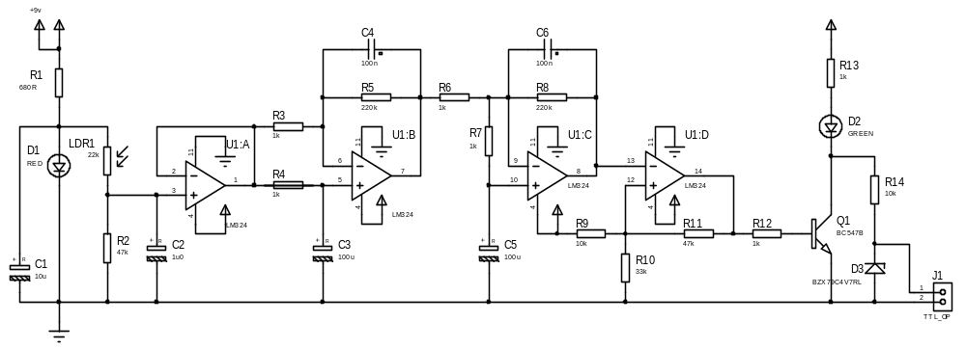

Figure 4 – Circuit Diagram

PCB Component and Layout
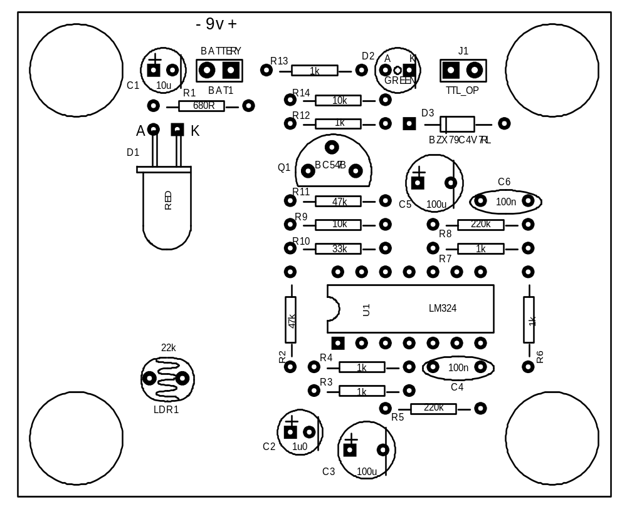

Figure 5 Component Layout

Parts List

Quantity | Value | Component Ref. | Description
1 | 680R | R1 | Blue, Grey, Black, Black, Brown
6 | 1k | R3,R4,R6,R7,R12,R13 | Brown, Black, Black, Brown, Brown
2 | 10k | R9,R14 | Brown, Black, Black, Red Brown
1 | 33k | R10 | Orange, Orange, Black, Red, Brown
2 | 47k | R2, R11 | Yellow, Purple, Black, Red, Brown
2 | 220k | R5, R8 | Red, Red, Black, Orange, Black
1 | LM324 | U1 | Dual Op Amp
1 | BC547B | Q1 | Transistor
1 | LED-RED | D1 | Light Emitting Diode (Clear)
1 | LED-Green | D2 | LED
1 |  | LDR1 | Light Dependent Resistor
2 | 100nF | C4, C6 | Ceramic Capacitor
1 | 1u0 | C2 | Electrolytic Capacitor
1 | 10uF | C1 | Electrolytic Capacitor
2 | 100uF | C3, C5 | Electrolytic Capacitor
1 |  | BAT1 | Battery Connector

Table 3

Component Recognition

Resistors

Band 1 | Band 2 | Band 3 | Band 4 | Band 5 | Value
See Figure 7 for colours of resistors in this project

Zener Diode
(Physical)

(Symbol)

LED
K
A
A
K
A K
LED (Symbol)

C B E
C
E
B
Transistor

Capacitor Electrolytic Ceramic

